Chapter 8, Solution 62.

Find the response v_{R}(t) for t > 0 in the circuit in Fig. 8.107. Let R = 3 Ω, L = 2 H, and C = 1/18 F.
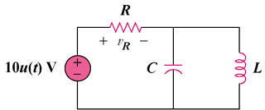

Figure 8.107
For Prob. 8.62.

Solution

This is a parallel RLC circuit as evident when the voltage source is turned off.

- = 1/(2RC) = (1)/(2x3x(1/18)) = 3

ω_{o} = 1/ = 1/ = 3

Since α = ω_{o}, we have a critically damped response.

s_{1,2} = -3

Let v(t) = capacitor voltage

Thus, v(t) = V_{s} + [(A + Bt)e^{-3t}] where V_{s} = 0

But -10 + v_{R} + v = 0 or v_{R} = 10 – v

Therefore v_{R} = 10 – [(A + Bt)e^{-3t}] where A and B are determined from initial conditions.

